1980 D
(a) Write the ground state electron configuration for an arsenic atom, showing the number of electrons in each subshell
(b) Give one permissible set of four quantum numbers for each of the outermost electrons in a single As atom when it is in its ground state.
(c) Is an isolated arsenic atom in the ground state paramagnetic or diamagnetic? Explain briefly.
(d) Explain how the electron configuration of the arsenic atom in the ground state is consistent with the existence of the following known compounds: Na3As, AsCl3, and AsF5.

1990 D
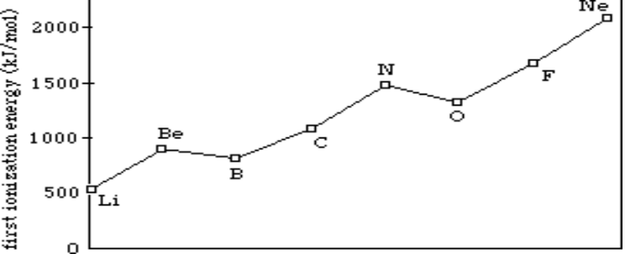
The diagram shows the first ionization energies for the elements from Li to Ne. Briefly (in one to three sentences) explain each of the following in terms of atomic structure.
(a) In general, there is an increase in the first ionization energy from Li to Ne.
(b) The first ionization energy of B is lower than that of Be.
(c) The first ionization energy of O is lower than that of N.
(d) Predict how the first ionization energy of Na compares to those of Li and of Ne. Explain.

